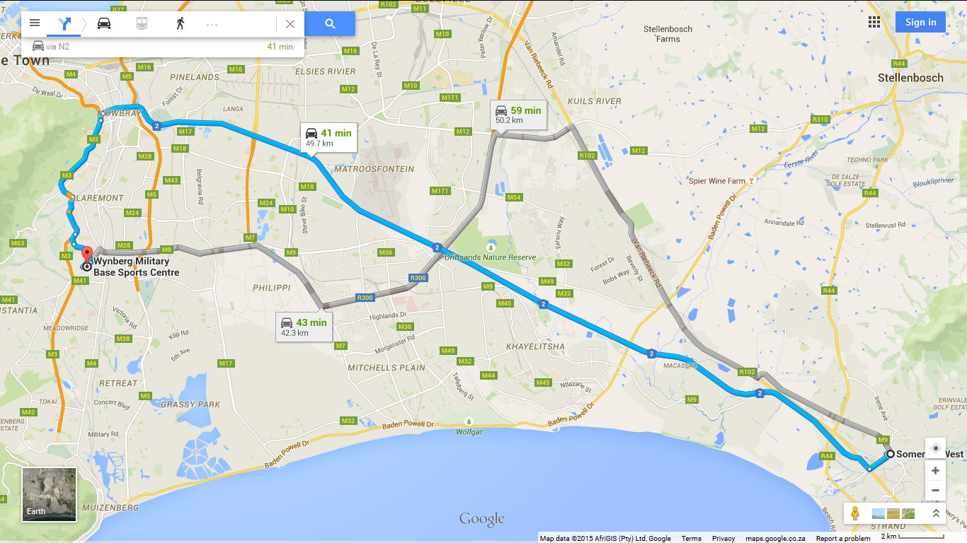
Somerset West
Cape Town, South Africa

Take Victoria St to N2
Head northeast on Victoria St toward Main Rd/M9
56 m

Turn left onto Main Rd/M9 120 m
Turn left onto Oak St 210 m
Turn left onto Andries Pretorius St 120 m

Turn right onto Victoria St 1.0 km

Continue on N2 to Newlands
Turn right onto N2 39.4 km
Take exit 6 for Rhodes Drive toward M3/Observatory/Muizenberg 400 m
Merge onto M3 4.3 km

Continue on M3. Take Waterloo Rd to Camp Rd in Wynberg
Keep right to continue on Paradise Rd/M3 Continue to follow M3 1.9 km
Take the Trovato Link ramp to M155/Wynberg 500 m
Continue onto Trovato Link 550 m
Continue onto Waterloo Rd 700 m
Turn right onto Jan Smuts Rd Restricted usage road 400 m

Jan Smuts Rd turns left and becomes Camp Rd Restricted usage road
Destination will be on the left 82 m

GPS Coordinates
-34.007655, 18.461157

